Equity Report

June 18, 2024

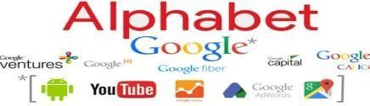

**Alphabet Inc. (NASDAQ: GOOG)**

**Price: $176.45 Rating: BUY**

**Target Price: $189.81**

Recent Earnings Call: June 10, 2024   
 Next Earnings Call: Jul 23, 2024

**Company Description**

The technology industry thrived during the early pandemic but faced challenges in recent years due to high inflation, elevated interest rates, and global uncertainties. These factors led to reduced consumer spending, lower demand, declining market capitalizations, and workforce reductions in 2022 and 2023. However, there are signs of a potential recovery in 2024, with reduced recession risks and optimism for modest growth.

Deloitte advised tech leaders to improve supply chain transparency, streamline business processes, adopt intelligent automation, modernize legacy systems with cloud and XaaS services, and expand into other industries using digital advancements. Building talent in AI, RPA, and cybersecurity was also emphasized.

Looking ahead, key trends for 2024 include:

1. Cloud, AI, and Cybersecurity: Expected to drive enterprise spending and growth.

2. Globalization vs. Self-Reliance: Balancing interconnectedness with risks from geopolitical unrest and supply chain issues.

3. Generative AI: Experimentation and application to enhance efficiency and productivity.

4. Regulations: Governments assessing the impact of large tech platforms and social networks.

.

|  |  |
| --- | --- |
| **DuPont Analysis** | |
| Tax Burden | 86.09% |
| Interest Burden | 99.64% |
| Operating Margin | 29.03% |
| Asset Turnover | 0.80 |
| Leverage Ratio | 2.92 |
| Adjusted ROE | 29.52 |

|  |  |
| --- | --- |
| **Valuation Metrics** | |
| Sector Communication Services | |
| Industry | Technology |
| Market Cap | $2.17 T |
| 52 Week Range | $115.83 - $179.95 |
| ROIC | 27% |
| P/E Ratio (TTM) | 24.97% |
| Beta | 1.01 |
| Price/Book | 7.46 |
| Price/Sales | 7.02 |
| Dividend yield | -- |
| 1 – Year Return | 58.27% |
| Enterprise Value | 2.09 T |

Alphabet Inc. was established in 2015 as part of a corporate restructuring, with Google becoming its largest subsidiary. Google's products and services are widely used as the world's largest search engine, smartphone operating systems and various internet-based tools and platforms like YouTube.

Alphabet encompasses a vast array of other holdings, including Chrome, Gmail, Google Drive, Google Maps, Google Photos, Google Play, Search and other bets.

The major sales of Google come from Google Services (about 90% of sales) which includes advertising that accounts for 80% of sales, sales of apps, in-app purchases, digital content products, and hardware; and fees received for subscription-based products such as YouTube Premium and YouTube TV and the rest 10% of sales are generated from Google Cloud platform.

Investment in R&D development, data centers and IT assets and funding money into mergers & acquisition are the key skills of the company to expand their business.

|  |  |
| --- | --- |
| **Financial Metrics (TTM)** | |
| Net Revenue | $318,146,00 |
| Net Income | $82406 |
| Gross Profit | $181714 |
| Interest Coverage | 298.60 |
| Current Ratio | 2.15 |
| ROA | 20.70% |
| ROE | 29.50% |
| Earnings/Assets | -- |

**Industry Overview**

**Diluted EPS**

**Sales (In Billion)**

|  |  |  |  |  |  |
| --- | --- | --- | --- | --- | --- |
| Year | Q1 | Q2 | Q3 | Q4 | FY |
| **2021** | 1.31 | 1.36 | 1.30 | 1.40 | 2.72 |
| y/y | 143.65% | 219.20% | 81.56% | 45.47% | 17% |
| **2022** | 1.23 | 1.21 | 1.06 | 1.05 | 4.56 |
| y/y | -6.35% | -11.23% | -18.74% | -24.97% | -18.72% |
| **2023** | 1.17 | 1.44 | 1.55 | 1.64 | 5.80 |
| y/y | -4.96% | 19.01% | 46.23% | 56.19% | 27.19% |

|  |  |  |  |  |  |
| --- | --- | --- | --- | --- | --- |
| Year | Q1 | Q2 | Q3 | Q4 | FY |
| **2021** | 55.31 | 61.88 | 65.12 | 75.33 | 257.64 |
| y/y | 34.39% | 61.58% | 41.03% | 32.39% | 41.15% |
| **2022** | 68.01 | 69.69 | 69.09 | 76.05 | 282.84 |
| y/y | 22.95% | 12.61% | 6.10% | 0.96% | 9.78% |
| **2023** | 69.7 | 74.60 | 76.69 | 86.31 | 307.39 |
| **y/y** | 2.61% | 7.06% | 11% | 13.49% | 8.68% |

**Alphabet Price**

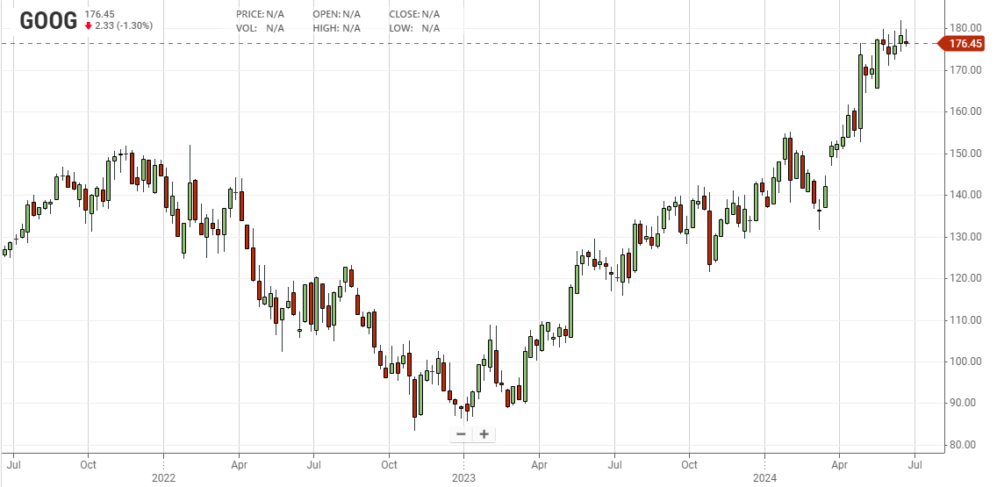

**Risks**

The barriers that could harm Google's business, reputation, financial condition, and operating results, and can affect the trading price of our Class A and Class C stock.

* A large amount of revenue is generated from advertising and user engagement. Reduced spending by advertisers, a loss of partners, or new and existing technologies that block ads or affect their ability to customize ads could harm their business.
* Retaining and maintaining highly skilled employees & continuing to adapt corporate culture.
* Changes in regulations related to privacy, data protection, intellectual property, and other areas could significantly impact its operations and profitability.
* Antitrust laws and violations can be a major risk for the company and thus it has paid fines to the EU for violating it.
* Intense competition can be a challenge and thus innovation is required to survive in this industry.
* Handling large amounts of user data can result in data breaches, hacking, malware, phishing attacks, and cybersecurity issues.
* Fluctuations in macroeconomic indicators like consumer spending, advertising budgets, and interest rates can affect the business.
* Emerging technologies like Gemini are unable to generate images of white people and Bard was not able to compete with other Competitors like Open AI.
* Access usage of other devices other than traditional desktops may benefit revenues but adversely affect their margins.
* Disruptions in the supply chain can lead to increased costs and inventory shortages.
* Revenue from international markets can be affected by currency exchange risk.
* A share repurchase program could increase the volatility of stock prices and could diminish the cash reserves of the company.

**Porter’s 5 forces**

**Competitive rivalry or competition:** Competitive rivalry limits Alphabet's growth in the technology and online services industry. Alphabet’s products face competition from:

1. Consumer electronics of Apple, Microsoft, and Samsung.
2. Digital advertising services of Facebook and eBay.
3. Internet connectivity services of Verizon.
4. Movie streaming services of Amazon and Disney

**Bargaining power of buyers:** While Google’s services are mostly free for users, the abundance of advertising options limits   
direct bargaining power. However, in hardware markets, buyer bargaining power is lower due to Google’s strong brand recognition and reputation.

**Bargaining power of suppliers:** The availability of numerous suppliers minimizes their bargaining power against Google. Most suppliers are small compared to Google, allowing the company to impose demands and leverage its size to increase margins. However, dominant suppliers like Nvidia can influence profitability. Occasionally, defects or recalls in purchased components can also impact margins.

**The threat of substitutes or substitution:** The threat of substitutes significantly impacts Google. For instance, when Bard underperformed compared to OpenAI, Google's stock price fell by 10%, causing a $100 billion loss in stock value within a week. Moderate switching costs exist between Google and alternatives like Bing for search engines and Facebook for advertising. High availability of substitutes and low to moderate performance-to-price ratios, such as expensive but effective TV advertising, can divert user attention and advertising budgets away from Google's ecosystem.

**Threat of new entrants:** The threat of new entrants moderately influences Google’s business. Lower startup costs create moderate impacts, but high brand development costs and Google’s established brand pose significant barriers. Additionally, Google’s massive data centers and infrastructure deter new entrants from sustaining in the industry

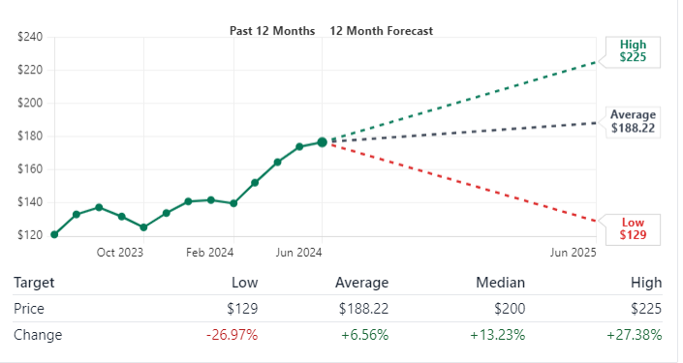

**Future Plans** - Alphabet's Future Plans

Alphabet CEO Sundar Pichai announced several structural changes aimed at improving the company's velocity and execution. These changes focus on four key areas:

1. Models and Research:

- Consolidation of teams building AI models within Google DeepMind to accelerate AI development.

- Google Research will continue investing in foundational and applied computer science in computing systems, foundational ML, and applied science and society.

2. Responsible AI:

- Integration of Responsible AI teams into Google DeepMind to enhance accountability and safety in AI development.

- Increased investments in AI testing, standardizing launch requirements for AI features, and bolstering "red team" testing for vulnerabilities.

3. Platforms and Devices:

- Formalizing the collaboration between DSPA and P&E into a new Platforms & Devices PA.

- Moving computational photography and on-device intelligence teams to this new organization to integrate AI across hardware and software.

- Rick Osterloh will oversee Platforms & Devices, with Sameer Samat leading the Android ecosystem.

4. Mission Focus:

- Emphasizing the importance of focused, professional conduct to support the company's mission of organizing the world’s information.

- Encouraging a culture of open discussion while maintaining a business-focused environment.

These changes are designed to streamline decision-making, enhance collaboration, and ensure the responsible development and deployment of AI, ultimately driving higher-quality products and experiences for users and partners.

As of 2024, Google maintains its dominance in the search market with a 91% market share and remains the leading digital advertising platform. Alphabet has strategically diversified its business beyond advertising, investing in sectors such as autonomous vehicles (Waymo), hardware (Pixel smartphones), life sciences (Verily), and generative AI, notably with the introduction of Gemini. This diversification reduces Alphabet's reliance on any single revenue stream and positions the company for future growth across multiple industries. Gemini, a natively multimodal AI tool, is designed to surpass Microsoft-backed OpenAI in various areas, including text, audio, code, video, and image generation, and outperforms GPT-4 in general tasks, reasoning, math, and coding.

Alphabet's strong balance sheet and ample cash reserves enable strategic investments, acquisitions, and asset returns. Financial projections estimate that by 2025, Alphabet will generate $333.49 billion in revenue with a 10.50% sales growth, yielding $205.30 billion in profit. The company is expected to grow at a rate of 19.25% over the next five years, with earnings per share anticipated to grow at a CAGR of 15.24% until 2025, indicating robust performance and profitability.

Despite current stock volatility, market trends suggest that Alphabet remains a growth-oriented and long-term investment. Overall, Alphabet's strategic diversification, strong financial foundation, and innovative advancements position it well for sustained growth and profitability in the years ahead.



**Investment Thesis**

**- Sarang Gaikwad**